**Self-Assessment 3-3**

3. How many address lines and how many data lines are required for the following RAM memories? How many bytes can each memory store?

1. 32K words x 8 bits/word
2. 16M words x 32 bits/word
3. 4G words x 64 bits/word

For part *a* only, draw a block diagram showing all pins to the bus that connects the RAM to the outside world.

**Answer**

***Please maximize your window to see the answer clearly.***

1. 32K words x 8 bits/word

The number of address lines and data lines required for a 32K word x 8 bits/word RAM are shown below:

|  |  |  |  |
| --- | --- | --- | --- |
|  | **Address Lines** | **Data Lines** |  |
| 32K x 8 = 215 x 8 | 15 | 8 |  |
|  |  |  |  |
| (32K words x 8 bits per word) 8 bits/byte | = 215 = 32 Kbytes |  |  |

The following block diagram shows the pins to the bus that connects the RAM to the outside world:

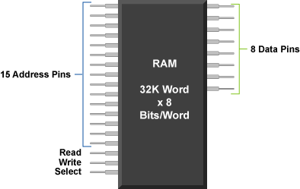

1. 16M words x 32 bits/word

The number of address lines and data lines required for a 16M word x 32 bits/word RAM are shown  below:

|  |  |  |  |
| --- | --- | --- | --- |
|  | **Address Lines** | **Data Lines** |  |
| 16M x 32 = 224 x 32 | 24 | 32 |  |
|  |  |  |  |
| (16M words x 32 bits per word) 8 bits/byte | = 226 bytes = 64 Mbytes |  |  |
|  |  |  |  |

1. 4G words x 64 bits/word

The number of address lines and data lines required for a 4G wordx 64 bits/word RAM are shown below:

|  |  |  |  |
| --- | --- | --- | --- |
|  | **Address Lines** | **Data Lines** |  |
| 4G x 64 = 232 x 64 | 32 | 64 |  |
|  |  |  |  |
| (4G words x 64 bits per word) 8 bits/byte | = 235 = 32 Gbytes |  |  |